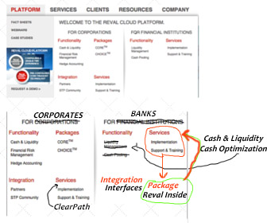

Link following links to the following URLs:

**Cash & Liquidity:**

Physical: [www.reval.com/Pages/cash-and-liquidity.aspx](http://www.reval.com/Pages/cash-and-liquidity.aspx)

Friendly: [www.reval.com/for-banks/cash-and-liqudity](http://www.reval.com/for-banks/cash-and-liqudity)

**Cash Optimization:**

Physical: [www.reval.com/Pages/cash-optimization.aspx](http://www.reval.com/Pages/cash-optimization.aspx)

Friendly: [www.reval.com/for-banks/cash-optimization](http://www.reval.com/for-banks/cash-optimization)

**Reval Inside:**

Physical: [www.reval.com/Pages/package-reval-inside.aspx](http://www.reval.com/Pages/package-reval-inside.aspx)

Friendly: [www.reval.com/for-banks/reval-inside](http://www.reval.com/for-banks/reval-inside)

**Interfaces:**

Physical: [www.reval.com/Pages/system-integration.aspx](http://www.reval.com/Pages/system-integration.aspx)

Friendly: [www.reval.com/for-banks/interfaces](http://www.reval.com/for-banks/interfaces)

**ClearPath:**

Physical: [www.reval.com/Pages/reval-clearpath.aspx](http://www.reval.com/Pages/reval-clearpath.aspx)

Friendly: [www.reval.com/reval-clearpath](http://www.reval.com/reval-clearpath)